A Basic Understanding of Radar

By
Christopher A. Rynas

A MASTER OF ENGINEERING REPORT

Submitted to the College of Engineering at
Texas Tech University in
Partial Fulfillment of
The Requirements for the
Degree of

MASTER OF ENGINEERING

Approved

______________________________________
Dr. J. Smith

______________________________________
Dr. A. Ertas

______________________________________
Dr. T. Maxwell

______________________________________
Dr. M. Tanik

October 18, 2003

ACKNOWLEDGEMENTS

I would like to take this opportunity to thank Texas Tech University, the instructors that made the trip to Dallas to teach, the Raytheon personnel for administering the program, and Dr. Atila Ertas for organizing and executing the Raytheon Masters of Engineering program. In addition, I would like to take this opportunity to thank Dennis Delzer for his effort in providing invaluable feedback during the creation of this report. I would also like to take this time to reiterate my thanks to Dr. Atila Ertas for his month-to-month leadership, guidance, and helpfulness throughout the program. Finally, I would like to express my thanks to Dr. Tanik for his insight in quantum computing.
I would also like to express my thanks to my wife and son for enduring my inattentive behavior and/or absence during the past year. Their unselfish support has allowed me the time to attend class, study, and recover from the long grueling weekends.

TABLE OF CONTENTS
ACKNOWLEDGEMENTS ii
DISCLAIMER v
ABSTRACT vi
LIST OF FIGURES vii
LIST OF TABLES x
NOMENCLATURE xi
CHAPTER I INTRODUCTION 1
CHAPTER II BACKGROUND 3
2.1 An Abbreviated History of Radar 3
CHAPTER III INTRODUCTION TO RADAR 9
3.1 Radar Basics 9
CHAPTER IV RADAR ARCHITECTURE 17
4.1 Radar System 17
4.2 Antenna 17
4.2.1 Omni Antenna 18
4.2.2 Directional Antenna 21
4.2.3 Antenna Servo Control 23
4.2.5 Electronically Scanned Array 24
4.2.6 Planar Array 27
4.3 Duplexer 29
4.4 Receivers 30
4.4.1 Mixers 30
4.4.2 Filtering 32
4.4.3 Amplification 33
4.4.4 Analog to Digital Converter (ADC) 34
4.4.5 I and Q Outputs 34
4.5 Exciter 35
4.5.1 Local Oscillator 36
4.5.2 Up/Down Conversion 36
4.5.3 Waveform Generator 38
4.6 Transmitters 39
4.6.1 Radar Equation 39
4.6.2 Radar Cross Section 40
4.6.3 Magnetron 40
4.6.4 Traveling Wave Tube 43
4.6.5 Transmitter Unit 45
4.7 Radar Control Processor 45
4.7.1 Transmitter Interface 47
4.7.2 Receiver Interface 47
4.7.3 Exciter Interface 49
4.7.4 Video Processor Interface 49
4.8 Video Processor 50
4.9 Display 54
4.9.1 Planned Position Indicator Display 55
4.9.2 A-Scan Display 58
4.9.3 B-Scan Display 58
4.9.4 C-Scan Display 60
4.9.5 Ground Map 60
4.9.6 ISAR Imagery 62
CHAPTER V CURRENT AND FUTURE STATE OF RADAR 64
REFERENCES 67

DISCLAIMER

The information contained within this report is based on the knowledge gained during my Raytheon career. Sources of knowledge came from day-to-day work experiences while working on programs such as the AN/APS-137 radar in McKinney Texas, the IFF Mark XV program, and the HiTeP program in Dallas. In addition, sources of knowledge came from radar classes taught by Raytheon Institute of Learning as well as numerous library and college textbooks.
The opinions expressed in this report are strictly those of the author and are not necessarily those of Raytheon, Texas Tech University, nor any U.S. Government agency.
ABSTRACT

Basic radar concepts and ideas started in the late 1800s. Radar has and continues to evolve at a steady pace. Each year, new ideas, concepts, and technologies are developed that increases the capabilities and performance of radar systems. Because radar capabilities, performance, and technology continue to improve, the quantity of applications continues to rise. There are numerous applications today including microwave ovens in our kitchens, X-Ray and sonograms in our hospitals, air-traffic control in our airports, weather and navigation radar in our airplanes, ground mapping radar in our defense spy satellites, collision avoidance radar in our airplanes and automobiles, and various other applications.
Given that radar is part of our everyday life, the engineering community must have a basic understanding of the history of radar, the concepts behind radar, and the physical units that make up the radar. It is the intent of this report to address each of these topics in such a way that it makes the reader comfortable with radar.

LIST OF FIGURES

Figure 1. Radar Set SCR-268 (courtesy of US Army camp Evans). 4
Figure 2. AN/FPS-16 Radar (courtesy of Naval Air Warfare Center). 5
Figure 3. AN/FPS-85 Ground Based Radar (courtesy of Global Security). 6
Figure 4. AN/APG-73 AESA Radar for F/A-18 (courtesy of Naval Air Command). 7
Figure 5. Future Naval Ship – DD21 (courtesy of Raytheon). 8
Figure 6. Basic Radar Architecture. 9
Figure 7. CW Radar System. 10
Figure 8. Passive Radar System. 11
Figure 9. Pulsed Radar System. 11
Figure 10. Bi-Static Radar - Pulse or Continuous Wave. 12
Figure 11. Radar Line of Sight. 13
Figure 12. Radar Range. 13
Figure 13. Conventional Radar RF Spectrum. 15
Figure 14. Detailed Radar System. 17
Figure 15. Omni Antenna (courtesy of Broadcast Microwave Services). 18
Figure 16. Flat Omni Antenna (courtesy of Broadcast Microwave Services). 18
Figure 17. Omni Antenna Azimuth Pattern (courtesy of Flann Microwave). 19
Figure 18. Omni Antenna Elevation Pattern (courtesy of Flann Microwave). 20
Figure 19. Omni-Directional Antenna (MD-248) (courtesy of Flann Microwave). 20
Figure 20. Directional Antenna – Transmit. 21
Figure 21. Directional Antenna – Receive. 22
Figure 22. Directional Antenna (courtesy of Lorenzen). 22
Figure 23. SSEC Antenna (courtesy of Space Science and Engineering Center). 24
Figure 24. Example of Electronically Scanned Antenna (ESA). 26
Figure 25. Active Electrically Scanned Antenna (AESA) (courtsey of Technology Focus). 26
Figure 26. AESA Patriot Antenna (courtesy of US Army Technology). 27
Figure 27. An/APG-65 with Planar Antenna (courtesy of Naval Technology). 28
Figure 28. Planar Array Corporate Feed (courtesy of Remcom). 28
Figure 29. Duplexer. 29
Figure 30. Duplexer Photo (courtesy of Microwave Devices). 30
Figure 31. Basic Radar Receiver. 31
Figure 32. Single Down Conversion Process. 31
Figure 33. Dual Down Conversion Process. 32
Figure 34. Down Conversion Filtering. 33
Figure 35. Automatic Gain Control Feature. 34
Figure 36. Example of an Advanced Radar Receiver. 35
Figure 37. Basic Exciter Block Diagram. 36
Figure 38. Exciter Multipliers. 37
Figure 39. Linear FM Chirp Waveform (courtesy of Murray Greenman). 39
Figure 40. Sectional View of a Typical Magnetron (courtesy of Michael Wagner). 41
Figure 41. Electron Motion in a Magnetron (courtesy of Michael Wagner). 42
Figure 42. Antenna Port Connection to Magnetron Tube (courtesy of Michael Wagner). 42
Figure 43. TWT Photo (courtesy of Abex). 44
Figure 44. Sectional View of a Typical TWT (courtesy of Lycos). 44
Figure 45. Typical Transmitter Block Diagram. 45
Figure 46. Radar Control Processor Interfaces. 46
Figure 47. Radar Control Processor. 47
Figure 48. Transmitter Interface. 48
Figure 49. Receiver Interface. 48
Figure 50. Exciter Interface. 49
Figure 51. Video Processor Interface. 50
Figure 52. Video Processor Block Diagram. 52
Figure 53. TWS Overlay Symbols Laid Over PPI Display (courtesy of AN/APS-137). 54
Figure 54. Cockpit Using LCDs (courtesy Northrop Grumman). 55
Figure 55. PPI Display. 56
Figure 56. Typical Weather Radar PPI Display (courtesy NEXRAD Radar). 57
Figure 57. PPI Display with TWS Enabled (courtesy AN/APS-137). 57
Figure 58. A-Scan Display. 58
Figure 59. B-Scan Display. 59
Figure 60. PPI Display with B-Scan Window (courtesy AN/APS-137). 59
Figure 61. C-Scan Display. 61
Figure 62. Patch Display of San Fernando Valley, California. 61
Figure 63. Typical SAR Image (courtesy of AN/APS-137). 62
Figure 64. Typical ISAR Display (courtesy of AN/APS-137). 63

LIST OF TABLES
Table 1. IEEE RF Band Nomenclature 16
Table 2. Waveform Types. 38
Table 3. Typical Radar Cross Section Values (courtsey of Pozar). 40

NOMENCLATURE

AC – Alternating Current

ADC – Analog to Digital Converter

AESA - Active Electronically Scanned Array

AEW - Airborne Early Warning

AGC – Automatic Gain Control

CW – Continuous Wave

DC – Direct Current

DSP - Digital Signal Processing

ESA – Electronically Scanned Array

ICBM – Intercontinental Ballistic Missile

IF – Intermediate Frequencies

ISAR - Inverse Synthetic Aperture Radar

LO – Local Oscillator

MMIC - Monolithic Microwave Integrated Circuit

MTI – Moving Target Indicator

RF – Radio Frequencies

SAR – Synthetic Aperture Radar

STALO – Stable Local Oscillator

T/R – Transmit/Receive

TWS – Track-While-Scan

UAV – Unmanned Air Vehicle

CHAPTER I INTRODUCTION

Radar plays a vital role for all of us today. Radar stands for Radio Detection and Ranging. It provides us with an early warning against serious weather like thunderstorms, tornados, and hurricanes. It provides our military with several different applications such as targeting weapons, electronic warfare for self-protection and removal of enemy air defenses, and ground mapping for battle damage assessment. Radar also plays a vital role in our national defenses. Our government agencies are able to image the total earth surface using satellite-based radars. Using satellite-based radars, our government is able to watch the development of weapons of mass destruction, troop build-ups, and the list goes on.
There is no better device/system to determine the range and bearing of an object than the radar. The radar is able to determine the range of an object (how far it is from the radar) by calculating how long it took from the time the transmitted pulses left the radar to the time it took for the echo (returned pulse) to return to the radar. The radar is also able to determine the angle of the reflected radio wave by rotating its antenna to determine the source of the reflection. Not only can the radar determine the distance and bearing (angle) of an object from the radar, but it can also determine its Doppler frequency shift. The Doppler frequency shift is used to discern stationary targets from moving targets. By consistently calculating the Doppler frequency of an object, the radar can determine coarse and speed of the target. Targets can be as simple as a cluster of thunderstorms where meteorologists look for Doppler shifts, or rotations within the storms for tornadic activity to complex targets like incoming missiles moving an extremely high rate of speed.
Radar has the capability to operate in bad weather such as cloudy days and rainy conditions. Radar also has the capability to operate in total darkness since it relies on RF (radio frequency) signal reflections from object. These capabilities makes radar an extremely important system to various applications discussed above and listed below:

- Air-traffic control at major airports
- Aircraft navigation
- Naval navigation
- Weather detection and prediction
- Space applications for docking with other spacecraft
- Mapping the earth
- Law-enforcement for speed measurement
- Military applications that include reconnaissance, target detection and tracking, navigation, battle damage assessment, and target acquisition.
The objective of this report is to provide the reader with a brief history of radar, the basic understanding of radar, and examples of various architectures.

CHAPTER II BACKGROUND

2.1 An Abbreviated History of Radar
Early on, it was discovered that most objects, when bombarded with a series of radio waves, would reflect them (more like a scattering effect) upon impact. Consider the bat that has no eyesight and relies on its radar-like capability to fly around, gather prey, and return home using a radar-like method. The bat communicates, or sends out in this case, a series of shrill noises. These shrill noises, reflected off surfaces back to the bat, are used to avoid obstacles and home in on its prey [Stimson, 1983]. It was concepts like these that led engineers to develop a system that would detect and display objects in order to determine its location and distance. The system which engineers developed was/is called radar (RAdio Detection And Ranging).
Radar uses electromagnetic waves for detection and location of objects. The radar system generates and transmits a predefined waveform, detects the received echo, and displays the echo (target) on a display. [Skolnik, 1988] Heinrich Hertz, in 1886, tested the theories of Maxwell and demonstrated the similarity between radio and light waves. Hertz showed that radio waves could be reflected by metallic and dielectric bodies. In 1903, a German scientist experimented with the detection of radio wave reflected from ships. The Germans demonstrated the reflected waves, but were unable to operate at long distances. In 1922, Marconi told an audience during a speech that it is possible to design an apparatus that would transmit radio waves at a ship and receive the reflected radio waves that would then reveal the presence of another ship with its range and bearing attributes. Even though the exact date that radar was developed is not known (probably started near the turn of the century), many use 1935 as the starting date of radar development since many papers, demonstrations, and serious developments began at that time. In the 30’s, several countries presented papers and demonstrated their radar systems and capabilities simultaneously.
By the end of 1934, three engineers from Naval Research Laboratory in Washington, DC detected an aircraft using a 60 MHz pulsed radar. The following year, in Great Britain, an engineer was able to detect an aircraft using bi-static radar. That same year, the French were testing radars with different wavelengths (radar frequencies). The same year, the Germans demonstrated a 600 MHz radar on a naval ship. Concurrently, the Italians began testing radar to detect people and vehicles. The same year, the Russians began detecting aircraft at various distances with different power levels and antenna types. The following year, 1936, the Japanese proposed and demonstrated the Doppler radar principle [Skolnik, 1988]. As shown in Figure 1, the SCR-268 radar was developed in the mid 30’s by the US Army to detect and track aircraft. The SCR-268 radar remained operational for several years until the Germans rendered it useless in the early 40’s by jamming its receiver.
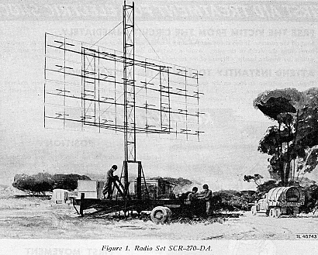
Figure 1. Radar Set SCR-268 (courtesy of US Army camp Evans).

The need to provide bombers with long distance targeting capability and provide allies cities with anti-aircraft defense catapulted radar technology and development in several countries simultaneously in the forties. The Germans were, for the most part, the leaders in radar development. Several key developments emerged during the forties that set the foundation of radar technology as we see it today. The SCR-548 was designed as a replacement for the SCR-268/270 series of radars. The SCR-548 was the first radar that provided the necessary angular position accuracy that allowed allies to turn-off searchlights or optics.
In the fifties, higher power amplifiers were developed allowing the range of aircraft detection to increase as well as ballistic missile detection. Angular measurements made by radars continued to improve with precision instrumentation in antennas and receivers. As shown in Figure 2, the AN/FPS-16 radar was very successful radar built in the early 50’s. The success of the AN/FPS-16 radar was due to its angular position accuracy.

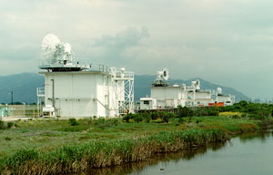
Figure 2. AN/FPS-16 Radar (courtesy of Naval Air Warfare Center).

The first synthetic aperture radar (SAR) was demonstrated (a SAR radar is an airborne radar used to map the ground). The SAR capability is used in many radar systems today and the resolution of the images produced by this radar continues to improve with time. Airborne weather avoidance and ground based weather observation radars were also developed.
The sixties saw the advent of the first Solid State Phased Array Radar. Solid State Phased Array Radars consist of both Electronically Scanned Arrays (ESA) and Active Electronic Scanned Array. In addition, the sixties began the start of digital signal processing. Instead of rotating an antenna to point at a particular object, phase shifters were used to steer the beam to a particular location. Due to the control of the phase shifters, the digital processor made significant advances in an effort to keep up with the technology demand. More and more functions were implemented in digital hardware as opposed to analog hardware – a trend continuing today. Moving target indicator (MTI) radars first took to the skies on board the E2 AEW (Airborne Early Warning) platform. The first set of ground-based radars like the one shown in Figure 3, were developed to detect and track space based satellites and installed in the southern US. During the sixties, electronic counter measures were developed to counter enemy radar jamming to avoid degrading the radars performance.

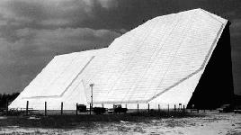
Figure 3. AN/FPS-85 Ground Based Radar (courtesy of Global Security).

During the seventies, digital signal processing (DSP) continued to make inroads. DSP improved the accuracy of the radar in several areas such as MTI, SAR, and ISAR (Inverse Synthetic Aperture Radar). A bi-product of the Vietnam era was radar that was capable of penetrating the earth for tunnel detection/location. Today the radar penetration capability is used to locate mineral deposits, detect underground bunkers, and several other uses.
From the eighties to today, radar has continued to improve. The Navy’s primary air defense attack fighter (F/A-18) recently received a targeting upgrade that employs an AESA antenna as shown in Figure 4. Naval ships of the future will integrate dozens of applications (types of radar using multiple antennas) into a single electronically scanned array as shown in Figure 5. As processing technology continues to improve at a rate close to Moore’s law, radar systems continue to shrink in size thus allowing the same capability in a smaller size or more capability in the same size. Weather observation and systems continue to improve increasing the length of time from severe weather (tornadoes, hail, etc) detection to public alarm activation.
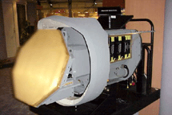
Figure 4. AN/APG-79 AESA Radar for F/A-18 (courtesy of Naval Air Command).

Ballistic missile defense continues to improve with detection that is more accurate along with increased tracking capabilities. No longer is missile defense used only detection and tracking ICBMs, but it now provides for detection and tracking of smaller missiles traveling at rates 10 to 20 times faster. Ballistic missile defense is no longer limited to ground applications and now is being planned/deployed on Navy ships. Airport surveillance radars continue to improve through more accurate radar detection and tracking, thus making the skies much safer for air travel.

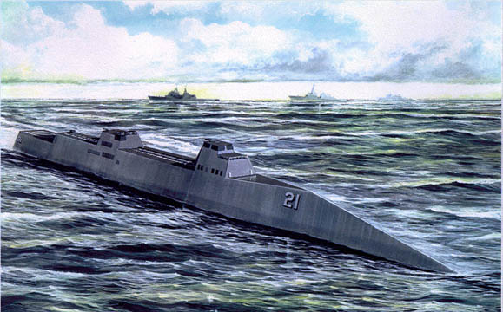
Figure 5. Future Naval Ship – DD21 (courtesy of Raytheon).

If not for the requirements of the military, radar would have progressed at a much slower rate over the years. The need for self-defense, better targeting, better range capability, and smaller size systems drove the rate at which radar technology developed over the past 65 years. The military today must be able to perform its mission in adverse weather conditions and be immune from jamming while not being a target for hostile enemies. As technology continues to improve, the military needs follow.

CHAPTER III INTRODUCTION TO RADAR

3.1 Radar Basics
Radio waves and light emit a flow of electromagnetic energy. Light waves have higher frequencies while radio waves have longer wavelengths or shorter frequencies. Shorter frequencies allow radio waves to penetrate the earth’s atmosphere without degradation. [Stimson, 1983] By detecting the reflected waves (echo), it is possible to identify objects at night, through haze, smog, fog, or clouds.
As shown in Figure 6, the most basic radar architecture consists of two antennas, a transmitter, a receiver, and a display. In this most basic radar architecture, the transmitter transmits a continuous frequency and passes the frequency on to the transmit antenna.

Display

Receiver

Transmit
Antenna

Transmitter

Receive
Antenna

Figure 6. Basic Radar Architecture.

The transmit antenna radiates the continuous wave signal at a fixed frequency received from the transmitter. The receive antenna accepts incoming continuous wave signals and passes the RF signal on to the receiver. The receiver continuously converts incoming electromagnetic waves and sends the converted information to the display for the operator to evaluate. When target echo’s are received by the receiver, the amplitude of the echo’s are much higher in amplitude when compared to non-target returns (either clutter or noise). The receiver continuously updates the display as new information is received. In the early days of radar, the bright spot (high amplitude signal generated by the receiver) on the display was called a blip.
Radars come in several varieties. For example, radars consist of CW radar systems, passive radars systems, and pulsed radar systems. In CW radar systems as shown in Figure 7, the transmitter generates and transmits a continuous signal at the same time the returned signal (echo) is being received. In CW radar systems, the returned signals (echo), from the target are shifted in frequency when compared to the transmitted frequency, thus a target has been detected. Range measurements cannot be made with a CW radar system. The CW radar system is used to examine the Doppler effect on the returned signal. To obtain range measurements using a CW radar, the continuous wave is modulated to extend the bandwidth of the transmitted wave.

Transmitter

Receiver
Antenna

Target
Control
Processor/
Data
Storage

Signal
Processor

Display

Figure 7. CW Radar System.

In passive radar systems as shown in Figure 8, the received signals (echo) from the target may have been created by the target via its own transmitter or the target reflected a signal from some other known source. A pulsed radar system as shown in Figure 9, transmits a pulse rather than a continuous wave signal. The pulsed radar system also utilizes a single antenna for both transmitting and receiving.

Receiver

Target
Control
Processor/
Data
Storage

Signal
Processor

Display

Figure 8. Passive Radar System.

Receiver

Target
Control
Processor/
Data
Storage

Signal
Processor

Display

Transmitter

Diplexer

Antenna

Figure 9. Pulsed Radar System.

Bi-static radars, as shown in Figure 10, have their transmitters and receivers separated by a considerable distance. If the radar system employs additional receivers while still using one transmitter, the system is called multi-static. Unlike the mono-static radar (one antenna for transmit and receive) that is hemispherical, the bi-static radar is planar. To make a bi-static radar hemispherical, both transmit and receive antenna would need to rotate in unison – extremely difficult if separated by large distances.

Receiver

Target

Transmitter
Transmitted Signal
Scattered Signal
Direct Signal

Figure 10. Bi-Static Radar - Pulse or Continuous Wave.

To be detected by most high frequency radars, a target must be within the line of sight. As shown in Figure 11, the radar is unable to detect the target since the target is hidden behind the mountains. Several drivers are important to radar detection. [Stimson, 1983] The major drivers include:
- Power transmitted by the radar
- Size of the radar antenna – antenna area
- Reflecting characteristics of the target – Radar reflectivity or radar cross section
- Wavelength of the transmitted wave – Determined by the radars frequency
- Strength of background noise or clutter
- Noise figure and detection sensitivity of the receiver


Target

Figure 11. Radar Line of Sight.

The “range” to a target as illustrated in Figure 12 is determined by the time it takes for the transmitted pulse to complete it’s round trip from the transmitter back to it’s receiver. The signal transmission occurs at the speed of light. The range to a target is ½ of the total time calculated by the receiver.
Range
Transmitted Pulse
Target
Time
Received Echo

Figure 12. Radar Range.

To cover 360 degrees of azimuth (horizontal) coverage for applications such as weather radar, radar antennas must be rotated. As the antenna is being rotated, the transmitter is pulsed. The position of the antenna as the reflected pulse is received determines the azimuth location or bearing (angle) of a target.
For tracking targets in applications like air traffic control, the movement of each target must be tracked in time to accurately illustrate the position of each target. Target tracking is accomplished by continually rotating the antenna and updating the display. For targets that are traveling at higher velocities, the rate at which the antenna rotates can be increased or the antenna can be stopped and positioned on the target of interest.
The term Doppler frequency relates to frequency shift between the transmitted signal and the received echo signal. As you listen to a helicopter as it approaches, passes, and flies away, it exhibits varying sound pitch depending upon where it is as it passes by. These sound variations are an example of the Doppler effect. Using severe weather as an example, meteorologists watch for significant frequency shifts in thunderstorms. Significant frequency shifts can denote tornadic activity. One side of a tornado will exhibit frequency that is increasing while the other side will exhibit frequencies that are decreasing relative to the transmitted frequency. The digital signal processor (receiver) calculates the frequency of each echo and displays the results for evaluation by the operator.
Radars make use of the Doppler effect in many applications. Fighter aircraft must use a radar mode called MTI. MTI allows the fighter pilot to pick out targets that are moving while filtering out unwanted signals and stationary targets. Without MTI, slow moving targets like tanks and SCUD launchers would appear to be stationary. As the targets move, the Doppler frequencies are calculated and target trajectories and rate of travel are displayed.
Ground mapping radar modes like SAR are heavily dependent on the reflecting properties of ground objects. Objects like lakes, metal roofs, grass, etc all exhibit different properties. The radar displays the different properties as differing amplitudes – brightness on the display. The reader must keep in mind that the radar map is different from a road map due to the wavelength differences found in radar versus visible light.
Frequencies used by radars today vary depending upon the application for which it is intended. As shown in Figure 13, radar covers a wide range of frequencies – 30 MHz to 40 GHz. Frequency is defined as the quantity of cycles in the wave per second (cycles per second term is named a Hertz). As new radar approaches are discovered, new frequencies may be required. As listed in Table 1, the conventional radar frequency range is subdivided into bands. Each band has its useful purpose. For instance, today’s global positioning satellite (GPS) system uses the frequencies allocated to L-band. X-band is used in many fighter aircraft for targeting, MTI, and SAR.

Audio
Radio
Infared
Visible
Ultra Violet
X-Rays
VLF
LF
MF
HF
VHF
UHF
SHF
EHF
AM - Radio
FM TV
Wave
Length
Frequency
100 KM
3 kHz
10 KM
1 KM
100 M
10 M
1 M
10 CM
1 CM
.1 CM
30 MHz
300 MHz
3 GHz
30 GHz
300 GHz
Conventional Radar
40 GHz

Figure 13. Conventional Radar RF Spectrum.

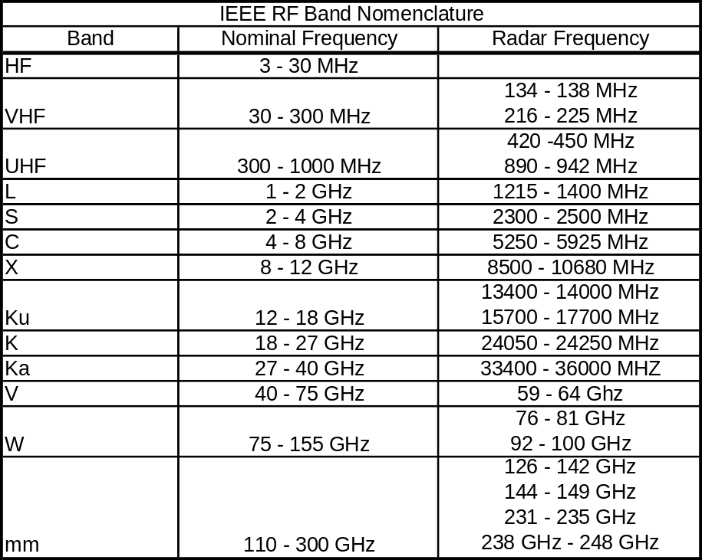
Table 1. IEEE RF Band Nomenclature

CHAPTER IV RADAR ARCHITECTURE

4.1 Radar System
As discussed earlier, the basic radar consists of an antenna, transmitter, receiver, and display. Radar systems today are far more complicated and require several different elements working in unison to operate correctly. A more detailed look into today’s radar systems is shown in Figure 14. The detailed radar system is comprised of several more elements including a single antenna, duplexer, transmitter, receiver, exciter, control processor, video processor, and a display. In this chapter, each of these elements will be discussed in more detail.

Antenna

Duplexer

Transmitter

Receiver

Exciter

Control
Processor

Video
Processor

Display

Figure 14. Detailed Radar System.

4.2 Antenna
An antenna is any device that is able to collect and/or radiate electromagnetic energy. There are two basic types of antennas – omni and directional. Examples of omni antenna would include car antennas, cell phone antennas, and CB radio antennas. Examples of directional antennas include satellite television, weather radar, and radar guns used for law enforcement.

4.2.1 Omni Antenna
Omni antennas radiate energy up to 360 degrees equally. Omni antennas can also receive energy up to 360 degrees. Since the omni antenna can cover 360 degrees, the amount of transmitted power must be great since it must cover 360 degrees. As shown in Figure 15 and Figure 16, omni antennas come in different shapes and sizes such as the post style antenna that covers 360 degrees and the flat antenna that covers 180 degrees. In Figure 17, the antenna pattern for an omni antenna that covers 360 degrees in azimuth (cross range) is shown by the circle in the figure. The size of the circle (radius) illustrates the gain of the antenna throughout the 360 degrees of azimuth. The greater the radius, the more gain the antenna has. The gain of the antenna depends upon the size of the antenna. Omni antennas usually have small gains when compared to directional antennas.


Figure 15. Omni Antenna (courtesy of Broadcast Microwave Services).

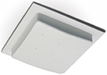
Figure 16. Flat Omni Antenna (courtesy of Broadcast Microwave Services).

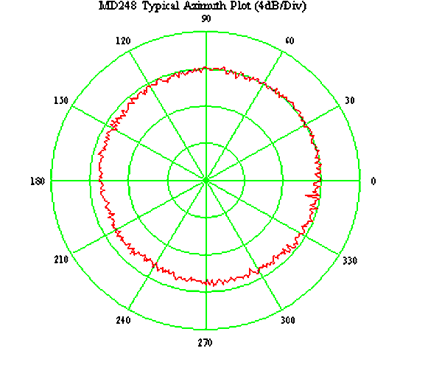
Figure 17. Omni Antenna Azimuth Pattern (courtesy of Flann Microwave).

A typical omni antenna elevation pattern is shown in Figure 18. The figure shows that the antenna has an effective elevation of 60 degrees (+/- 30 degrees from the center).
In some applications, it is necessary to have wide coverage in one direction and small coverage in another – omni directional antenna. An example of an omni-directional antenna is shown in Figure 19.
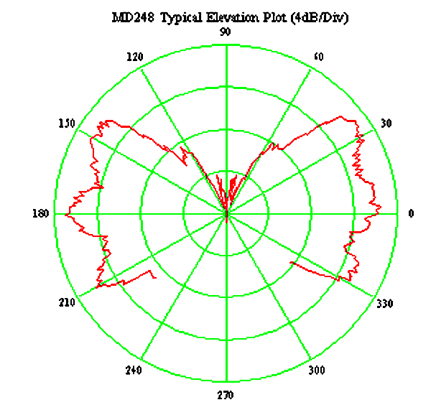
Figure 18. Omni Antenna Elevation Pattern (courtesy of Flann Microwave).

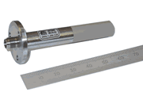
Figure 19. Omni-Directional Antenna (MD-248) (courtesy of Flann Microwave).

4.2.2 Directional Antenna
The other type of antenna is a directional antenna. The directional antenna focuses its transmitted energy to a particular area in space or ground. As shown in Figure 20 and Figure 21, most directional antennas use a parabolic dish and feed horn to focus transmitted and received electromagnetic energy.
A directional antenna’s beam width is narrow (four degrees) to focus it’s signal pattern in a particular point in space or on the ground. Since the directional antenna is only 4 degrees (beam width), this antenna has more gain than an omni antenna. The power that is required to reach (range) the same points of interest as the omni antenna is much smaller. The antenna pattern for a 4-degree directional antenna superimposed on a polar plot (similar to the 360 degree omni antenna pattern figure) would show a small pie shaped wedge equal to 4 degrees. A typical directional antenna used in satellite television is shown in Figure 22.
Transmitted Energy
Transmit Beam
Antenna Dish
Feed Horn

Figure 20. Directional Antenna – Transmit.

Received Energy
Receive Beam
Antenna Dish
Feed Horn

Figure 21. Directional Antenna – Receive.

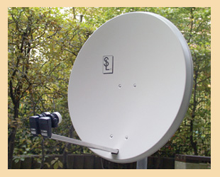
Figure 22. Directional Antenna (courtesy of Lorenzen).

4.2.3 Antenna Servo Control
For an application such as weather radar and air traffic control, the antenna must be rotated to cover 360 degrees and must be tilted (move the antenna up and down) in order to cover the entire sky. The element that rotates the antenna is called a servo that is a precision motor controller. The servo accepts digital or analog commands from the control processor and converts the commands in analog control voltages to control the motor that turns the antenna. In some applications, the antenna is tilted up and down to cover large volumes of space. Most radar antennas (Doppler or non-Doppler) are covered by dome-like physical structures called a radome as shown in Figure 4. Radome’s are used to protect the antenna from the environment without destroying the transmitted or received signal. Radome’s may be dome or igloo type structures. Some scanning antenna like marine antennas are visible and can be seen as they rotate in a circle in order to cover 360 degrees. As shown in Figure 23, some radar antennae include an azimuth drive for rotation and an elevation drive for tilt. The size of these motors and drive sprockets are large compared to the antenna mounted in the nose cone of a fighter jet, but the principle is identical – the antenna must be positioned to cover an area of interest.

Elevation Drive Motor

HNG

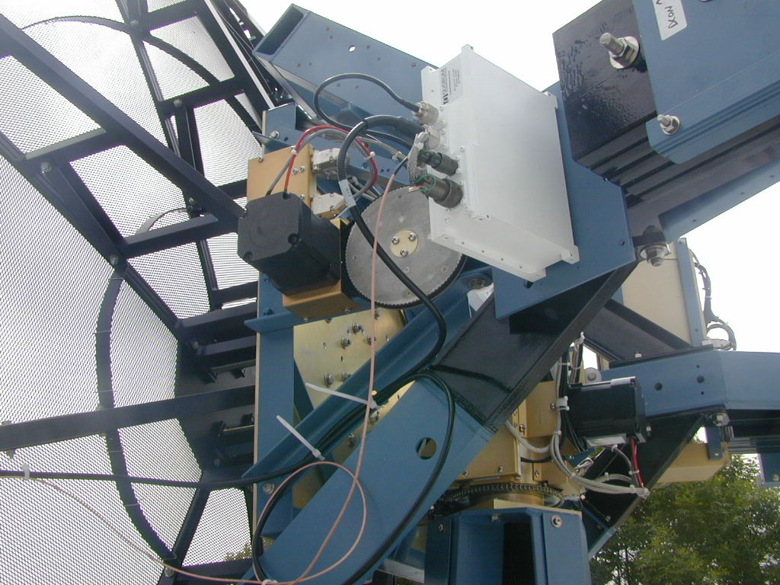
Azimuth Drive Motor

Figure 23. SSEC Antenna (courtesy of Space Science and Engineering Center).

4.2.5 Electronically Scanned Array
As stated earlier, Solid State Phased Array Radar come in two types – passive like the ESA and active like the AESA. The active electronically scanned array (AESA) was created in order to provide multiple functions (beams) simultaneously. With several beams being transmitted and/or received simultaneously, only one antenna is required for multiple applications. Massive ships like destroyers, frigates, and aircraft carriers with multiple antennas performing several tasks simultaneously can take advantage of the electronically scanned antenna. Each function like, UHF radio, VHF radio, radar search, high-speed missile detect, and target tracking can all be accomplished simultaneously using one electronically scanned antenna (ESA). Unlike the simple directional antenna with only one beam, the ESA can have a large number of beams – only limited to the power of the transmitted or received signal. An example of a multiple beam ESA is shown in Figure 24.
The ESA is much more complicated in operation and does not make use of servo mechanical motor controllers. The ESA requires pointing control from the control processor to point the beam in the correct position.
The ESA is defined as an array. The array is broken down into segments. Each segment is comprised of several phase shifters that shifts the electrical RF signal phase (steers the beam) of the electromagnetic wave/pulse being received and/or transmitted. Each phase shifter, when commanded by the control processor, changes the phase of the transmitted energy or the received energy. Within each segment, all phase shifters are commanded to point in the same desired position. In the example in Figure 24, there are four beams. Each beam can have more or less segments. To increase the antenna’s gain, more segments are assigned to that particular beam. Likewise, to increase the received signal strength, more segments can be used.
The AESA antenna (future AESA antenna for Rafael and the Typhoon, Eurofighter) shown in Figure 25, contains 1000 to 2000 transmit/receive (T/R) modules configured in multiple T/R interface modules (TRIM). Each TRIM contains several T/R modules. Each transmit/receive module in this antenna includes a radiator (antenna), transmitter, a receiver, and a scanning element. Each T/R module converts electric energy to electromagnetic waves using its own monolithic microwave integrated circuits (MMIC) that are inside each T/R module. For each row of T/R, there is a power supply. The AESA antenna shown in Figure 25, can be configured similar to the AESA antenna shown in Figure 24 through commands from the control processor.
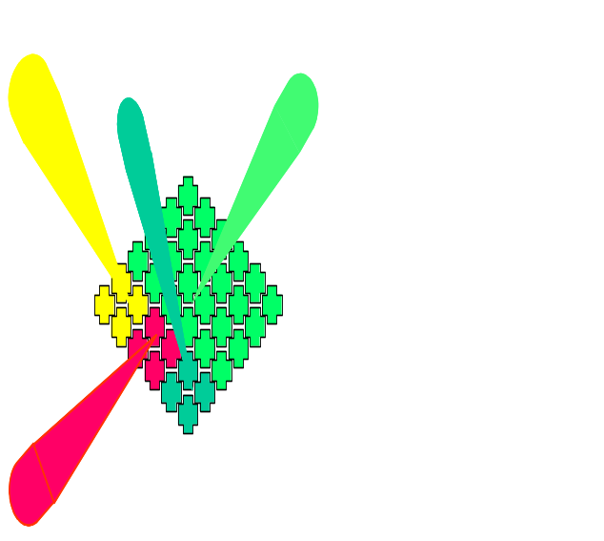

Figure 24. Example of Electronically Scanned Antenna (ESA).

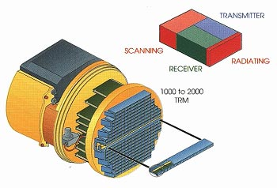
Figure 25. Active Electrically Scanned Antenna (AESA) (courtsey of Technology Focus).

The ESA offers another advantage over servo-scanned antennas. ESA offers quicker response time. It takes a fraction of time to point the ESA antenna versus the directional reflector using servos for positioning. Speed is one of many reasons the military is now using the Patriot antenna as shown in Figure 26. The Patriot radar uses several thousand T/R modules.

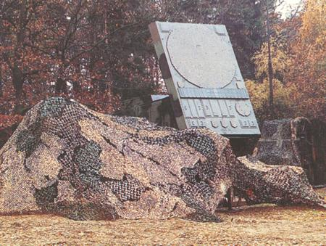
Figure 26. AESA Patriot Antenna (courtesy of US Army Technology).

4.2.6 Planar Array
Another type of antenna is the flat-faced planar array used in the AN/APG-65 radar for the F/A-18 aircraft as shown Figure 27. The planar array does not utilize the feed horn like the dish antenna instead it uses what is called a ‘corporate feed’ to collect radiated energy from each slot on the face of the antenna as shown in Figure 28. The planar array is used to increased angular resolution.

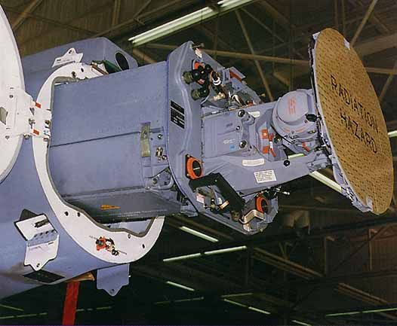

Figure 27. An/APG-65 with Planar Antenna (courtesy of Naval Technology).

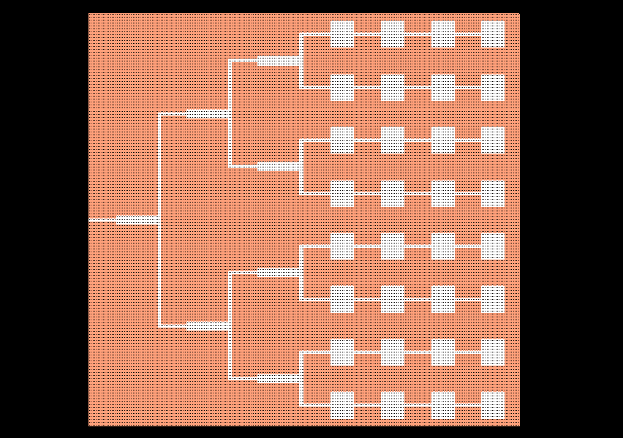

Figure 28. Planar Array Corporate Feed (courtesy of Remcom).

4.3 Duplexer
[Skolnik, 1970] Duplexers allow the radar to transmit and receive using one antenna. The use of one antenna is highly desirable for applications such as airborne fighters. The transmitter and receiver must share the time it uses the antenna. As shown in Figure 29, the duplexer is connected to the antenna, transmitter, and receiver. The duplexer allows high-power RF from the transmitter to pass through to the antenna without allowing high-power to pass into the receiver. Like wise, as RF is received from the antenna, it is passed along to the receiver without being coupled back into the transmitter. Typical duplexers/couplers are shown in Figure 30.
One example of sharing the antenna in a pulse radar application is where the transmitter is pulsed on and off at a periodic rate of 1ms (milliseconds). For each pulse, the transmitter is only active for 10us (microseconds). This leaves 990us for the receiver to down convert incoming RF signals. This process repeats unless the mode of the radar is stopped or changed.

Duplexer

RF to the Antenna

RF to the Receiver

RF from Transmitter

RF from the Antenna

Figure 29. Duplexer.

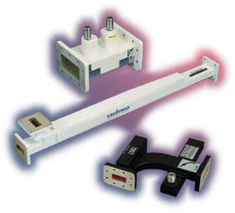
Figure 30. Duplexer Photo (courtesy of Microwave Devices).

4.4 Receivers
A radar receiver performs the following functions; 1) down-converts the incoming signal from the antenna to an intermediate RF frequency, 2) amplifies the signal, and 3) converts the amplified signal into digital signals for the video processor. A basic radar receiver block diagram is shown in Figure 31. More simply put, the receiver accepts RF signals and creates digital words that represent the strength of the input RF signal. As the input signal is converted, small signals are represented as small amplitudes, likewise, when strong signals are received, the conversion process represents them as large amplitudes.

4.4.1 Mixers
As shown in Figure 32, the down converter converts the incoming RF (radio frequency) frequencies into lower frequencies call IF (intermediate frequency) frequencies. The conversion is possible by subtracting the incoming RF frequency (f_{rf}) with a local oscillator (f_{rflo}). This subtraction process is made possible with the use of a mixer. One example is where we have a 10 GHz, X-Band radar signal (f_{rf}), as an input and a 100 MHz IF input (f_{if}) to the analog-to-digital (ADC) converter. The LO in this case would need to be 10 GHz (f_{rf}) – 100 MHz (f_{if}) = 9.9 GHz (f_{o}).

Down
Conversion
RF from Antenna

Amplification
Analog
to
Digital Conversion
Digital Data
To
Video Preprocessor

Figure 31. Basic Radar Receiver.

Mixer
RF from Antenna
IF to Amplifier

Local
Oscillator
f_{rflo}

f_{rf}

f_{rf} – f_{rflo} = f_{if}

B

L

LOB

Figure 32. Single Down Conversion Process.

Because of side effects caused by mixers, most receivers contain two down conversion processes as shown in Figure 33. The main side effects that mixers create are harmonics of the input RF and the LO used to down convert the RF signal. Harmonics can and do cause false targets because the video processor is unable to discern the difference.

Mixer
RF from Antenna
IF to Amplifier

Mixer

Local
Oscillator
f_{rflo}

T

K

f_{iflo}

T

K

F

?

f_{rf}

MIS

f_{rf} – f_{rflo} = f_{if1}

B

L

LOB

F
22

LOB

HNG

f_{if} – f_{iflo} = f_{if2}

B

L

LOB

Figure 33. Dual Down Conversion Process.

4.4.2 Filtering
Filtering in the down conversion process is an important feature. To keep unwanted signals out of the receiver, filters are added. Prior to the mixer, a pre-select filter is added to allow the signal of interest to pass into the receiver while rejecting unwanted signals. Consider an X-band radar operating at 10 GHz. The pre-select filter on the receivers input would need to allow the 10 GHz signal to pass while filtering out the unwanted signals.
This type of filter is called for a band-pass filter. Following the mixer in either the single or dual down conversion process as shown in Figure 34, filters are added to eliminate the harmonics created by the mixer and by the LO.

Mixer
RF from
Antenna
IF to
Amplifier

Mixer

Local
Oscillator

Pre-Select
Filter

Filter

Filter

Figure 34. Down Conversion Filtering.

4.4.3 Amplification
Amplification is another important part of the receiver. Signals received from long distances are weak. The receiver must amplify these weak received signals. The appropriate place for amplification in the receive chain is critical. Amplification in the wrong location can cause amplification of unwanted harmonics. Most receivers have the capability to operate in high signal strength areas while simultaneously trying to receive low signal strength signals. In order to receive all signal level amplitudes, the receiver must have an automatic gain control (AGC) feature. The automatic gain control feature automatically adjusts the gain of the receiver. In low signal strength areas, the automatic gain control adjusts the amplification to high. In the opposite condition, the automatic gain control feature adjusts the gain way down in high signal strength areas. As shown in Figure 35, the receiver has an amplifier in the front end to amplify all signals. The receiver also contains an amplifier and an attenuator after the filter on the first down conversion process. This attenuator is used to attenuate (lower) the received signal prior to the final stage of the down conversion process. The amplifier is used to increase the signal if the signal is still too weak while the attenuator is set to zero.

Mixer
RF from
Antenna
IF to
Amplifier

Mixer

Local
Oscillator

Filter

Filter

Filter

Amp

AGC
Atten

AGC

Figure 35. Automatic Gain Control Feature.

4.4.4 Analog to Digital Converter (ADC)
The final major part of the receiver is the ADC. The ADC receives the IF signal from the last filter in the down conversion process and converts it to digital signals for the video processor or words for the digital processor. There are several types of ADCs available today. The ADC examines the level of the analog (IF) input to estimate the voltage level, compares it preset voltage levels, and outputs a digital word.

4.4.5 I and Q Outputs
Radar receivers can operate in either a non-coherent mode or a coherent mode. For non-coherent systems, the transmitter and receiver are not synchronized in phase. For coherent radar systems, the transmitter and receiver synchronized in phase.
The receiver can generate several outputs where the outputs are dependant upon the radars requirements. The magnitude and log data as shown below are used for periscope detection, navigation, weather, and search and rescue modes where the coherent detector is used to support ISAR, SAR, and GMTI modes. The I/Q data received from the receiver can be represented in several different ways such as:
- I/Q data from a synchronous coherent detector
- Magnitude data from a square law detector - 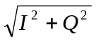
- Log data from a log detector - 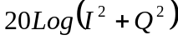
As described above, to support ISAR, SAR, and GMTI, the receiver must be a synchronous detector producing two separate outputs – one in-phase (I) and one quadrature phase (Q). As shown in Figure 36, the receiver outputs two separate digital words to the video processor. In order to accomplish the generation of the I and Q signals in the receiver, the receiver must replicate the last down conversion process by adding one additional mixer, another filter and an ADC. The first mixer uses the same frequency as the second mixer, but the frequency is 90 degrees out-of-phase.
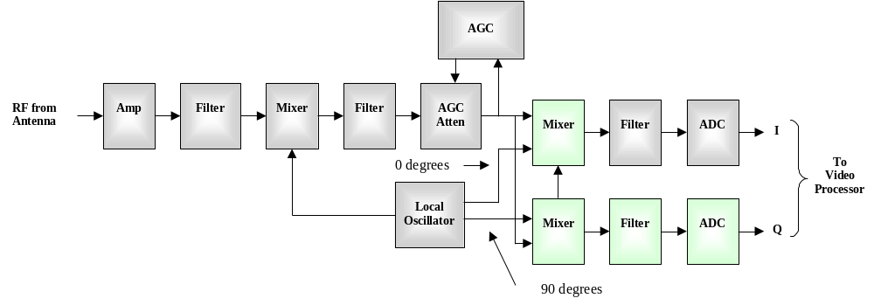
Figure 36. Example of an Advanced Radar Receiver.

4.5 Exciter
As shown in Figure 37, the exciter provides the reference local oscillator for the radar system, the up-converter local oscillators, down-converter local oscillators, and the waveforms that are sent to the transmitter for amplification. In most radar systems, the reference oscillator provides the single point of reference.
Exciter

Reference
Oscillator

Waveform
Generator

Receiver

Transmitter

HNG

MIS

Video
Processor

Antenna

HNG

MIS

Display

TOF
22

LOB

Figure 37. Basic Exciter Block Diagram.

4.5.1 Local Oscillator
Local oscillators must be extremely stable because small changes in frequency decrease detection capabilities (in both range and azimuth) and causes smearing in ground mapping images. For airborne applications, vibration plays a large role. As an oscillator is vibrated, its frequency changes. Oscillators must be designed to withstand vibration effects due to prop and jet engines with negligible effects on the frequency. Frequency is also impacted by temperature. As an oscillator goes through its warm up process and/or temperature variations, the frequency changes. To compensate for temperature variation, radars use heated or oven controlled oscillators. By the time, the radar has been turned on and ready to be used, the oven-controlled oscillator has warmed up and has reached its ‘sweet spot’ where variation in frequency is negligible.

4.5.2 Up/Down Conversion
As shown in Figure 38, the exciter supports both the down-conversion (subtract) process done in the receiver and the up-conversion (add) process done in the exciter. In either process, multipliers (denoted by the X) must be used to increase the frequency of the stable local oscillator (STALO) in order to reach the frequency of the 1st LO (RF LO) and the 2nd LO (IF LO).

Antenna

Mixer

Mixer

Mixer

Mixer

B

L

Waveform
Generator

B

L

F

ADC

B

L

F

MIS

STALO

B

L

F

MIS

HNG

X

B

L

F

MIS

HNG

TOF
22

LOB

X

B

L

F

MIS

HNG

TOF
22

LOB

1:2

B

L

F

MIS

HNG

TOF
22

LOB

OB

1:2

B

L

F

MIS

HNG

TOF
22

LOB

OB

1:2

B

L

F

MIS

HNG

TOF
22

LOB

OB

f_{rflo}

T

K

K

B

L

f_{rf}

T

K

K

B

L

HNG

MIS

F

?

T

f_{iflo}

T

K

K

B

L

HNG

MIS

F

?

T

LOF

?

T

K

B

L

HNG

MIS

f_{rf -} f_{rflo =} f_{if1}

T

K

K

B

L

HNG

MIS

F

?

T

f_{if1 –} f_{iflo =} f_{if2}

T

K

K

B

L

HNG

MIS

F

?

T

f_{if2}

T

K

K

B

L

HNG

MIS

F

?

T

LOF

?

T

K

B

L

HNG

MIS

f_{if2 +} f_{iflo =} f_{if1}

T

K

K

B

L

HNG

MIS

F

?

T

f_{if1 +} f_{rflo =} f_{rf}

T

K

K

B

L

HNG

MIS

F

?

T

Figure 38. Exciter Multipliers.

As discussed earlier in the receiver section, each time a mixer is used to up-convert or down-convert, unwanted harmonics are introduced. These unwanted harmonics must be filtered out. In the filter and mixing processes, the gain of the signal has been attenuated and must be amplified. In the case of the up-converted waveform for transmission, the gain is calculated and can be set using fixed amplifiers. In the receiver as discussed earlier, the gain must be adjusted automatically to keep the input to the ADC at the maximum value prior to saturation. With automatic gain control, the receiver is able to operate at its peak performance.

4.5.3 Waveform Generator
The waveform generator provides waveforms for transmission. The waveforms selected for a radar system depend upon its application for use. Table 2 lists three most common waveform types among radars today.
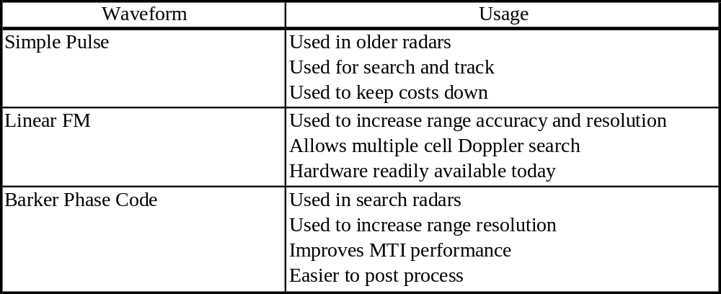
Table 2. Waveform Types.

For the simple pulse, the exciter generates a continuous sinusoidal wave and sends it to the transmitter. The transmitter pulses the sine wave when pulsed by the radar control function. For the linear FM waveform, the sinusoidal waveform is chirped during the transmit pulse. As shown in Figure 39, the waveform is named chirp since it starts out as a low frequency sine wave and ends up as a high frequency sine wave by the end of the transmit pulse – if converted into sound, it would chirp.

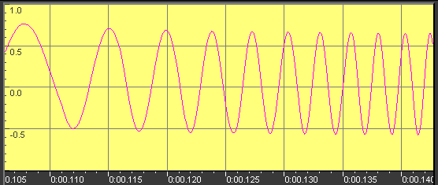
Figure 39. Linear FM Chirp Waveform (courtesy of Murray Greenman).

4.6 Transmitters

4.6.1 Radar Equation
To improve the radars capability to detect targets at greater distances, more transmitted power is required. [Skolnik, 1980] By examining the simplified radar range equation as shown in Equation 1, power plays a significant role in range detection. R_{max} defines the maximum distance a target must be away from a target to avoid detection, i.e., the maximum range at which the radar can detect a target – the two are interchangeable. The constant values such as antenna gain, the antenna effective aperture, the radar cross-section of the target (how much energy is reflected/scattered), and the receiver’s minimum detectable signal threshold also play significant roles, but have a smaller impact.
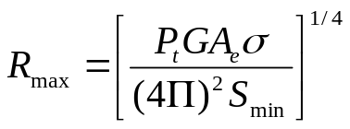

where P_{t} = transmitter power in watts
G = antenna gain
A_{e} = antenna effective aperture area, m2
σ = radar cross section of the target, m2
S_{min} = minimum detectable target signal, watts

Equation 1. Simplified Radar Range Equation.

4.6.2 Radar Cross Section
[Pozar, 1990] A radar target is characterized by its radar cross section, which gives the ratio of scattered power to incident power density. Table 3 lists a few targets and their associated radar cross- section values. The table shows larger targets have greater cross section values. Large cross section values provide increased radar detection range. It is easy to see why our military spent millions to develop the stealth fighter and bomber – decrease the radar cross-section value in order to become undetectable.
Table 3. Typical Radar Cross Section Values (courtsey of Pozar).

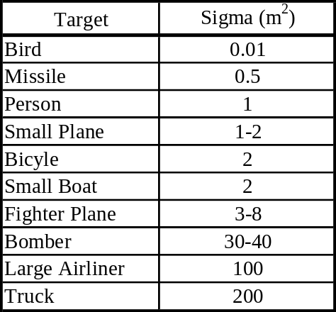

4.6.3 Magnetron
In early days of radar, the transmitter was no more than a large amplifier connected to an oscillator on one end and an antenna on the other end. The range at which targets could be detected was extremely limited because the amplifiers available were unable to generate the necessary power for longer distances. Due to limited range capability, radar was originally shunned as a technology not ready for application. In the late thirties and early forty’s, the magnetron was developed. The magnetron is capable of producing high-power magnetic waves. The magnetron is still being used today in several applications such as microwave ovens. A cross-sectional view of a magnetron is shown in Figure 40. The magnetron produces a high-power electromagnetic wave using magnetic fields and high direct current inputs. Electrons move from one direct current potential (anode) to the other direct current potential (cathode), shown in A of Figure 41. As the electrons move from one node to another, they pass through a magnetic field created by large magnets on either side of the tube, shown in B of Figure 41. As the electrons pass through the electronic field on their way to the anode, the path of the electrons are diverted (curved) by the magnetic field, shown in C of Figure 41. The cavity of the magnetron tube appears to “collect” the electronics as they rotate in a circle about the center, shown as D in Figure 41. While rotating about the middle of the magnetron tube as shown in Figure 42, the electrons pass each of the sub-cavities in the magnetron. As the electrons rotate past each sub-cavity, they oscillate and act as resonators. One of the sub-cavities of the magnetron cavity is selected as the antenna port.
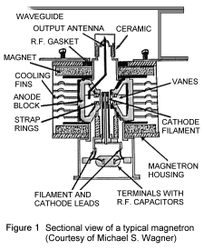
Figure 40. Sectional View of a Typical Magnetron (courtesy of Michael Wagner).

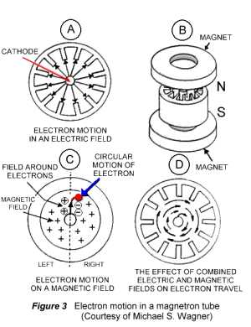
Figure 41. Electron Motion in a Magnetron (courtesy of Michael Wagner).

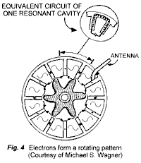
Figure 42. Antenna Port Connection to Magnetron Tube (courtesy of Michael Wagner).

4.6.4 Traveling Wave Tube
The next great invention in transmitters was the gridded traveling wave tube (TWT). The TWTs pictured in Figure 43 show current market offerings. [Stimson, 1983] The TWT produces higher power outputs with gains reaching 10 million with efficiencies of up to 50%. The TWT also brought quicker response time to turn on and off; coherence (repeatability) from one transmitted pulse to another transmitted pulse, and precise control of the radio frequency. R_{max}, the maximum range at which a target can be detected, increases dramatically.
Unlike the magnetron tube that accepts pulsating DC currents from the modulator, the traveling wave tube (TWT) receives a low-level RF signal from the exciter. As shown in Figure 44, the typical TWT consists of long tube with a cathode at one end and a collector at the other end. [Stimson, 1983] The cathode and collector produce a large electron beam through the center of the TWT. The helix coil is used to guide the signal from one end to the other as it is amplified. The collector at the end of the tube collects unused electrons. The unused electrons are recycled and used by the DC power supply. The magnets that surround the tube keep the electrons focused in the center of the tube. The signal is first introduced at the RF input. The signal then travels down the helix coil towards the collector. As the signal travels through the helix, it creates a sinusoidal electric field that travels down the center of the beam. [Stimson, 1983] The electrons on their way from the cathode to the collector speed up and slow down depending upon their charge (speed up for positive and slow down for negative). Pockets of positive and negative electrons form along the tube in the nulls (areas between pockets of positive electrons and negative electrons). The charged pockets of electrons amplify the signal as they make their way to the collector. The length of the helix drives the gain – the longer the helix, the higher the gain. At the end of the helix coil, the sinusoidal signal is coupled into a wave-guide port that connects to the antenna.

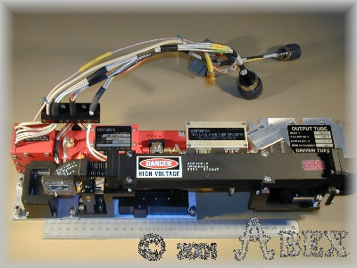
Figure 43. TWT Photo (courtesy of Abex).

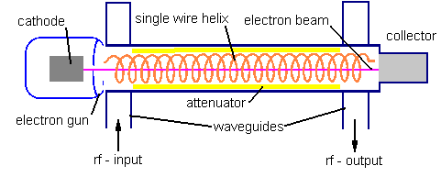
Figure 44. Sectional View of a Typical TWT (courtesy of Lycos).

4.6.5 Transmitter Unit
As shown in Figure 45, the typical transmitter is made up of four major components; 1) the input power converter, 2) the high voltage converter, 3) the grid modulator, and 4) the TWT for amplification. The input power converter converts standard 115-volt alternating current (AC) (60 cycle-single phase or 400 cycle-3 phase) power to a high voltage direct current (DC) signal. The high voltage converter converts the high voltage DC signal from the input power converter into higher DC voltages like –35,000 volts for the cathode and –20,000 volts for the collector through several amplification stages. The grid modulator accepts the transmit gate signal from the exciter and uses it to enable the grid voltages (switches them on and off with the transmit gate) when the transmit gate is active.

Input
Power
Converter

115 VAC

High-Voltage
Converter

LOB

Grid Modulator
&
Heater Power

TWT

LOB

RF from Exciter

RF to Antenna

LOB

Cathode

Collector

Cathode

Heater

High Voltage DC

Figure 45. Typical Transmitter Block Diagram.

4.7 Radar Control Processor
As shown in Figure 46, the radar control processor is the central command station of the radar. It receives commands from the host (processor that control the radar) and provides status back to the host upon request. The radar control processor is usually a general-purpose processor (single board computer).
For each of the received commands, the control processor must orchestrate the radar to operate correctly. The control processor also coordinates the designation and tracking of targets with the operator – the operator is only required to position the cursor over the target and activate for initiation. In some cases, the general purpose processor is used to host the target tracking and navigation algorithms in support of those functions. Finally, the radar control processor continuously monitors the health and operation of the system and notifies the operator via the display of problems. In the following sub-sections, each units interface is addressed.
The radar control processor, as shown in Figure 47, consists of a signal board computer (general purpose processor) and an interface card. The signal board computer is used to accept commands and provide status to the host computer/processor. The interface card is used to provide an interface to each of the radars units.

Transmitter

Receiver

Exciter

Control
Processor

Video
Processor

MIS

F

?

T

K

B

L

Host
Interface

Figure 46. Radar Control Processor Interfaces.

Radar Control Processor

Transmitter

Receiver

Exciter

Interface
Card
Video
Processor

MIS

F

?

T

K

B

L

Host
Interface

Single Board
Computer

Figure 47. Radar Control Processor.

4.7.1 Transmitter Interface
The transmitter usually has the least control as compared to other units of the radar. As shown in Figure 48, the control processor must be able to enable or disable the transmitter for maintenance in order to preserve a good measure of safety. In addition, the control processor must know when there is an error in the system. Finally, the transmitter must notify the control processor when it is warmed up and ready to operate. The transmitter (grid of the TWT) requires time to warm up. The warm up time from a cold start may take up to 5 minutes.

4.7.2 Receiver Interface
As shown in Figure 49, the receiver has more interface control signals than the transmitter. The operator may also want to increase the receiver gain via the radar control processor to better assess the targets on the display – this feature overrides the automatic gain control functionality of the receiver. The radar control processor must inform the receiver of how fast the system is running – pulse repetition frequency (PRF). The receiver uses the PRF rate to determine how long to process the incoming pulse. Finally, like all the other units of the radar system, the receiver notifies the radar control processor when there is a failure.

Transmitter

Control
Processor
Standby/Operate
Warmed Up
Transmitter Fail

Figure 48. Transmitter Interface.

Receiver

Control
Processor
Receiver Fail
PRF Rate

Warming Up
Receiver Gain

Warming Up
AGC On/Off

Figure 49. Receiver Interface.

4.7.3 Exciter Interface
The interfaces for the exciter are shown in Figure 50. The exciter is commanded to select a preprogrammed waveform by the control processor such as linear FM for SAR mode or Barker Code for Search and Rescue. Once the command is received, the exciter selects the preprogrammed waveform and starts its up-conversion. In addition, the control processor is able to disable the exciter’s RF to the transmitter with the RF disable command – one use for this command is during maintenance for safety. Some receivers have two different local oscillators in order to process different frequencies so, the control processor can command the exciter to output different local oscillators to the receiver. Finally, like all of the other units in the radar, the exciter notifies the control processor when it detects a failure.

Exciter

Control
Processor
Exciter Fail
Mode – Select Waveform

Warming Up
RF Disable

Warming Up
LO Selection

Warming Up

Figure 50. Exciter Interface.

4.7.4 Video Processor Interface
The video processor is where all of the incoming digitized video from the receiver is processed and sent to the display for evaluation by the operator(s). As shown in Figure 51, the video processor must receive a mode command from the control processor to determine what processing is to be done in the video processor. In some cases, the operator may want to control the threshold (noise versus target) within the receiver via the radar control processor. In addition, the operator may want to adjust the false alarm rate allowing more or less targets to be processed. As the false alarm rate is decreased, the receivers threshold for detecting targets in lowered which in turn allows more targets to be sent to the display. In addition, the video processor is responsible for tracking of all designated targets via the control processor.

Video
Processor

Control
Processor
Video Processor Fail
Overlay Control

Warming Up
PPI Threshold

Warming Up
False Alarm Rate

Warming Up
Mode

Warming Up
Tracker Information

Figure 51. Video Processor Interface.

Finally, the video processor is responsible for all of the graphical overlays that are sent to the display. Some of the overlays discussed later are inserted automatically based upon mode selected where other overlays are created and controlled by the control processor. The overlay control shown in the figure is used to provide a means for the control processor to insert overlays and control the overlays.

4.8 Video Processor
The video processor is responsible for accepting digitized data from the receiver, processing the digitized data, and sending it to the display for the operator to evaluate. This section will discuss the main processing functions within the video processor. There are two main processing paths with the video processor – a non-coherent path for processing modes not requiring frequency information such as weather and search and rescue and a coherent processing path for modes such as SAR and GMTI that are dependant on frequency content.
The video processor block diagram shown in Figure 52 shows two processing paths connected to the input memory. The I/Q data received from the receiver can be represented in several different ways such as:
- I/Q data from a synchronous coherent detector
- Magnitude data from a square law detector -
- Log data from a log detector -
These three outputs from the receiver (inputs to the Video Processor) support all of the radar modes discussed in this paper. The magnitude and log data are used for periscope detection, navigation, weather, and search and rescue modes. The coherent detector is used to support ISAR, SAR, and GMTI modes.
The input memory acts like as a buffer to ensure no data samples are lost during processing. For modes like periscope, navigation, weather and search and rescue, the incoming data stream is processed by a PPI threshold and detection circuit. The threshold and detection circuit must determine if the received sample meets a programmed threshold and integrates it with the value from the previous value. Following detection, the scan converter converts the input data stream from polar coordinates to X,Y for the display using a simple equation - 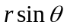 and 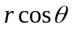 where r is the detected magnitude of the sample and θ is the antenna position in azimuth.
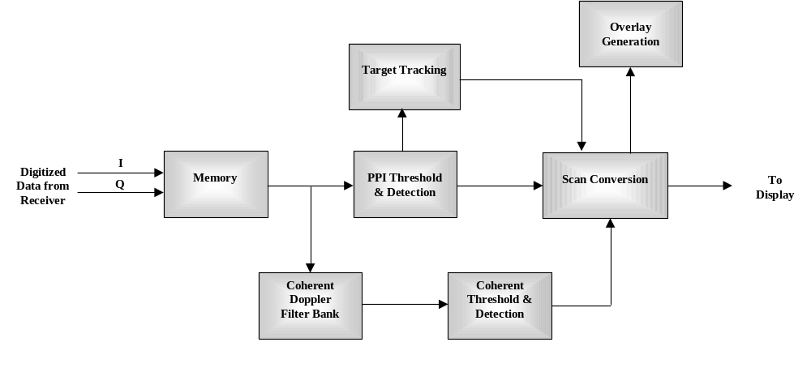
Figure 52. Video Processor Block Diagram.

For modes like ISAR, SAR, and GMTI the data is first processed in Doppler filter banks to calculate the frequency of each sample. Once the frequency content for each sample is known (range and cross range) for a given patch on the ground, the coherent threshold and detection circuitry calculates the magnitude of the frequencies and passes them along to the scan converter. The scan converter is not required to convert the data since the Doppler processing creates a ground map in X,Y format.
For some modes like navigation, the radar has the capability to track targets as they progress across the PPI display. As the target crosses the display, the radar connects the new location with the old location thus showing a trail of where the target was and which way it is heading. The tracker receives samples that exceeded the threshold defined in the detection circuitry. The threshold crossings are sent to a Kalman filter to estimate range-rate to obtain velocity and angle measurements. Even though a single target can be tracked, most radars use a tracker that has a mode called track-while-scan (TWS). The TWS mode is used to detect and track multiple targets simultaneously. If tracking multiple targets, the tracker must have multiple Kalman filters all executing simultaneously and a single control function that coordinates all targets.
The overlay generator is responsible for generating all of the overlays seen on the operators display. Overlays for the most part are used to aid the operator in his assessment of the situation. A good example of graphical overlays would include:
- Navigation/Weather/Search & Rescue
- Range Rings as shown in the display section of this report
- Heading marking depicting aircraft direction
- Tracking Symbols (refer to Figure 53)
- SAR/GMTI
- Aircraft Latitude/Longitude
- Aircraft Heading
- Altitude
- Ground Speed
- Cursor Latitude/Longitude
- Resolution
- Scene Geometry

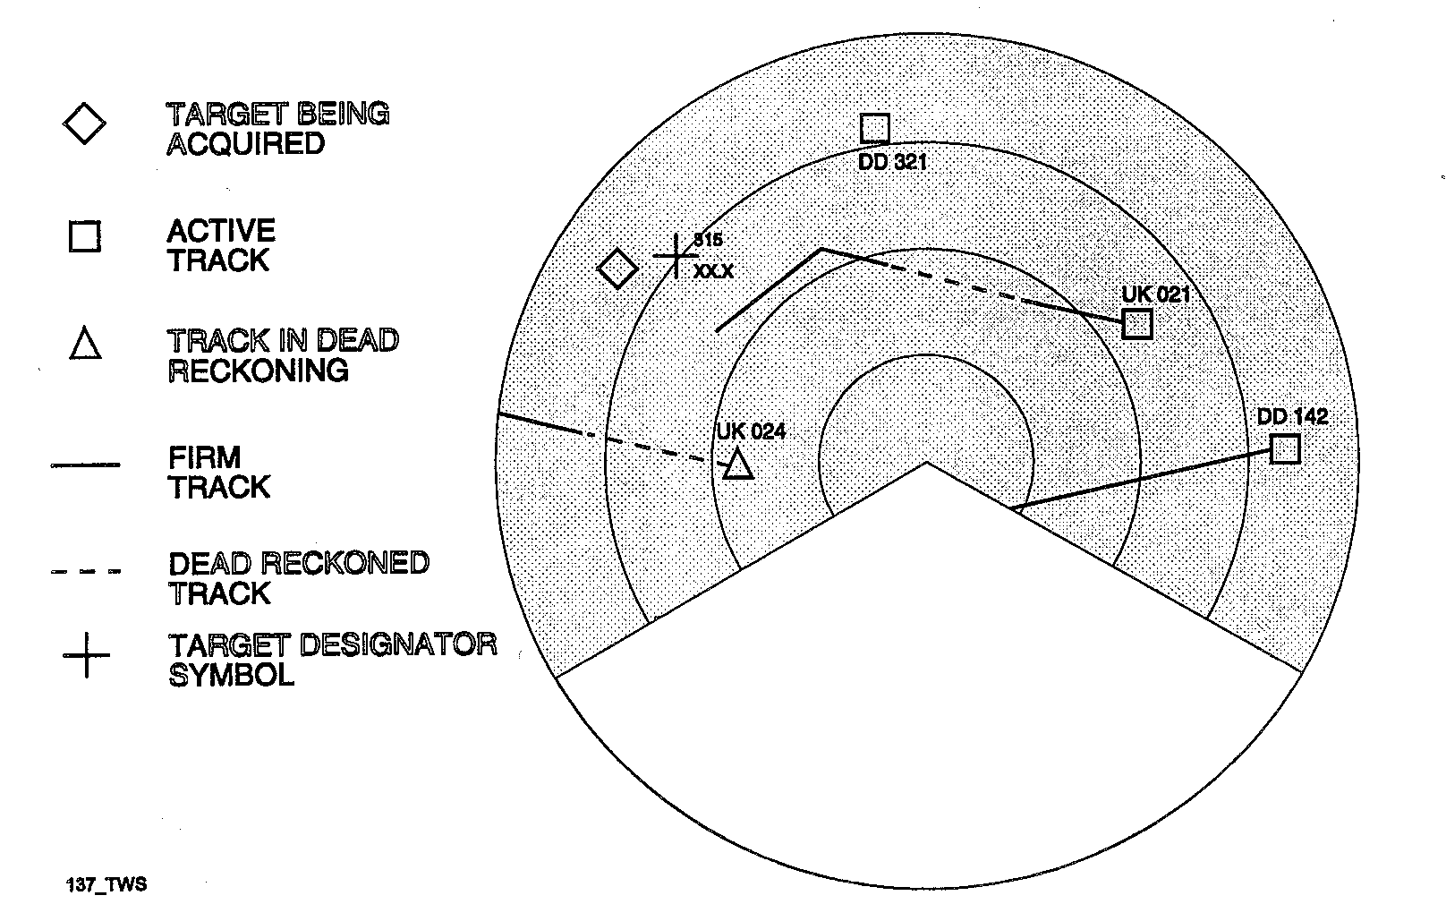

Figure 53. TWS Overlay Symbols Laid Over PPI Display (courtesy of AN/APS-137).

4.9 Display
The display is a key part of the radar system. The display is where the operator evaluates radar imagery and processing capabilities. There are several different types of radar displays available today. The most common displays from the 50’s to the 90’s were Cathode Ray Tubes (CRT) – the same type of display used in television. The output of the video processor for the CRT is an analog signal that is modulated (added to) on horizontal and vertical timing pulses. Today, many CRTs for radars and home use are being replaced by plasma or liquid crystal displays (LCD) like the ones shown in the cockpit of the fighter shown in Figure 54. For these types of displays, the output of the video processor to the LCD is digital that is similar to the connection made from your PC to its monitor.
The information being displayed depends upon the application the radar is intended. The following subsections illustrate and describe the most common displays used today.

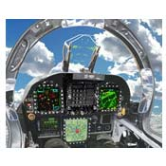
Figure 54. Cockpit Using LCDs (courtesy Northrop Grumman).

4.9.1 Planned Position Indicator Display
For search and rescue, weather, and ocean surveillance, the most common display is the PPI (Planned Position Indicator). The PPI display as shown in Figure 55, targets (dark spots) are displayed on a polar plot centered on the radars location. To discern range, range rings are generated and display in concentric circles about the center. The targets displayed in the PPI display can be aircraft, ships, weather, etc. The operator can quickly identify how far away (range) and what bearing the target is away from the radar.

90º
180º
270º
0º
R
A
N
G
E

Figure 55. PPI Display.

Typical weather radar displays as shown in Figure 56 and presented on local news channels utilize a PPI display. The weather display gives the viewer a quick sense of where severe weather is located because the video processor generated overlays indicating key points of interest such as towns and highways. Airport surveillance radars utilize the PPI screen as well for air-traffic control to track location and altitude of incoming and outgoing flights.
In Figure 57, the radar has enabled the track-while-scan (TWS) function. The TWS processing has annotated each target with a rectangular box. It is not at all uncommon to see hundreds of return echoed signals in harbor ports. The TWS function eliminates all non-targets through its processing and displays targets.

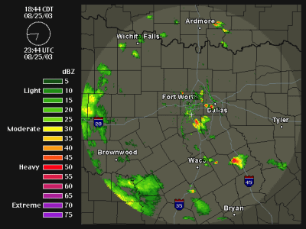
Figure 56. Typical Weather Radar PPI Display (courtesy NEXRAD Radar).

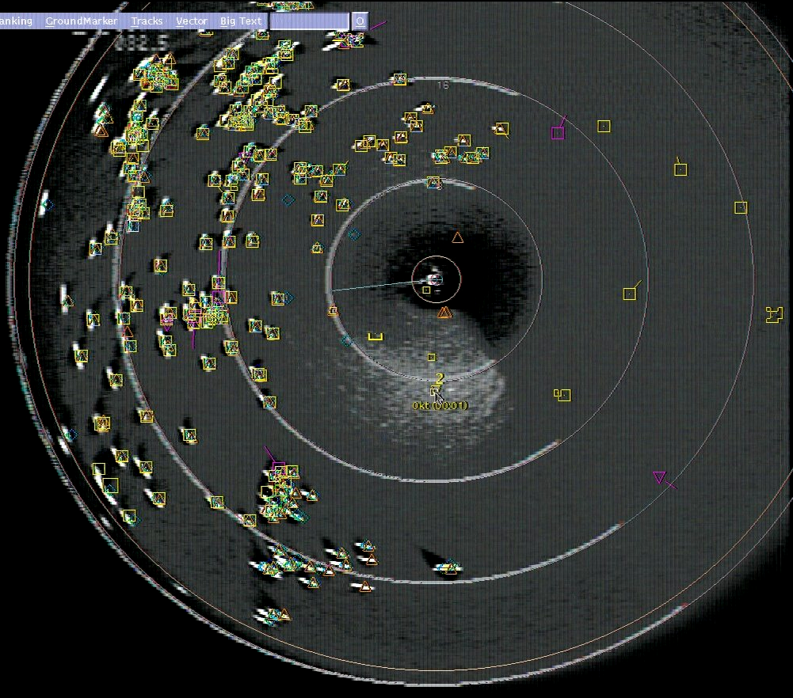

Figure 57. PPI Display with TWS Enabled (courtesy AN/APS-137).

4.9.2 A-Scan Display
[Stimson, 1983] A-Scan displays, or an amplitude scan, plot the receiver output versus range on a horizontal line. The A-Scan display is not used too often because it does not offer azimuth (bearing) information. A typical A-Scan display is shown in Figure 58.

4.9.3 B-Scan Display
The B-Scan display as shown in Figure 59 is used to display the same content as the PPI display except the display is arranged as range versus azimuth as opposed to polar. A B-Scan display allows navigation operators more accurate azimuth resolution. In some applications, operators prefer to use both PPI and B-Scan displays simultaneously as shown in Figure 60.
A
M
P
L
I
T
U
D
E
RANGE
Noise
Target/
Mountain

Figure 58. A-Scan Display.

R
A
N
G
E
BEARING
Target

Figure 59. B-Scan Display.
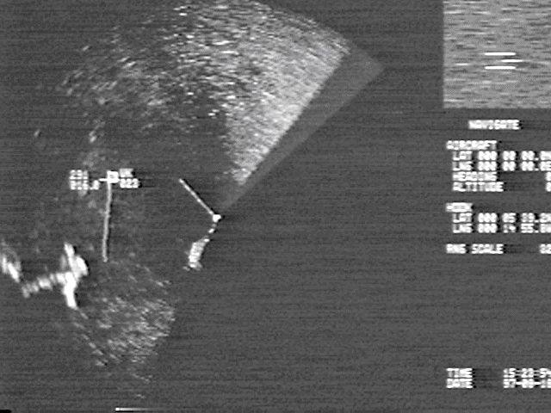

Figure 60. PPI Display with B-Scan Window (courtesy AN/APS-137).

In this display, the operator is using the B-Scan display window to initiate targets manually for targeting or tracking purposes.

4.9.4 C-Scan Display
C-Scan displays, or elevation scan, are mainly used for terrain following applications. To avoid radar detection from surface-to-air missile batteries, military aircraft must be able to fly “below the radars detection horizon” to avoid detection. To protect pilots from running into the ground or into a mountain, the terrain following radar was developed. A typical C-Scan display is shown in Figure 61.

4.9.5 Ground Map
A ground map is usually used to display a given area (patch) on the ground. The patch is displayed in range versus cross range as shown Figure 62. The most common usage of the patch display is used by radar modes called SAR (Synthetic Aperture Radar). Radar SAR modes are used by satellites and military aircraft as shown in Figure 63 to map a given area on the ground.

E
L
E
V
A
T
I
O
N
Azimuth
Noise
Target/
Mountain

Figure 61. C-Scan Display.

R
A
N
G
E
CROSS RANGE
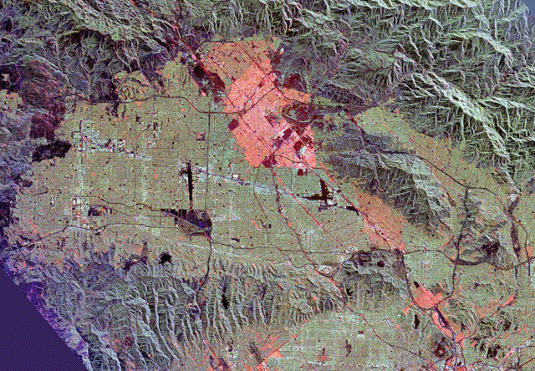

Figure 62. Patch Display of San Fernando Valley, California.

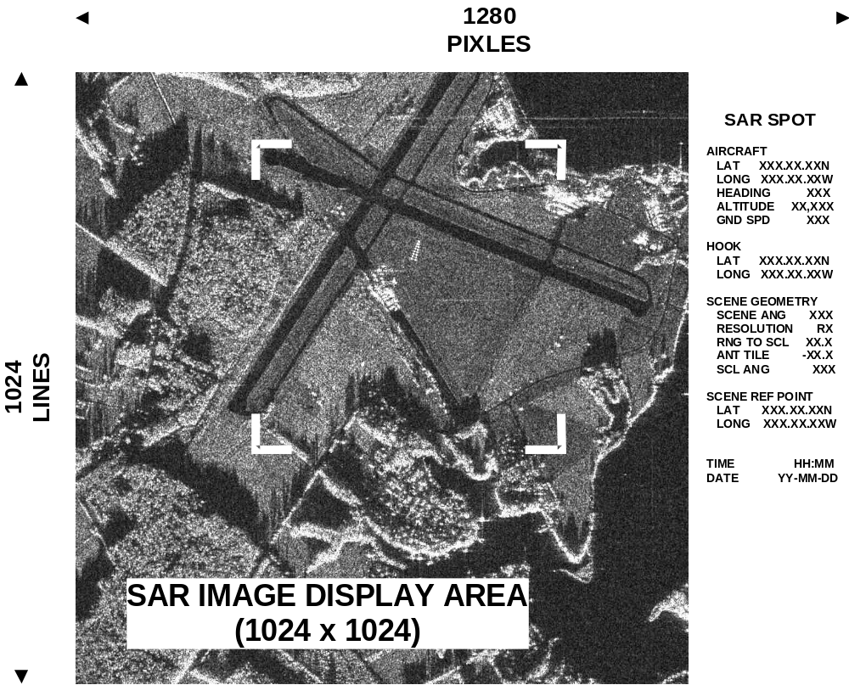

Figure 63. Typical SAR Image (courtesy of AN/APS-137).

4.9.6 ISAR Imagery
ISAR imagery unlike SAR depends upon on the motion (pitch, roll, yaw) of the target in order to create a display. Figure 64, shows a perfect example of an ISAR display. The photo on the left shows a taker being refueled by fuel barge. The ISAR image on the right shows the same two ships. The high intensity (bright white) pixels denote strong returns while low intensity pixels denote very weak returns.

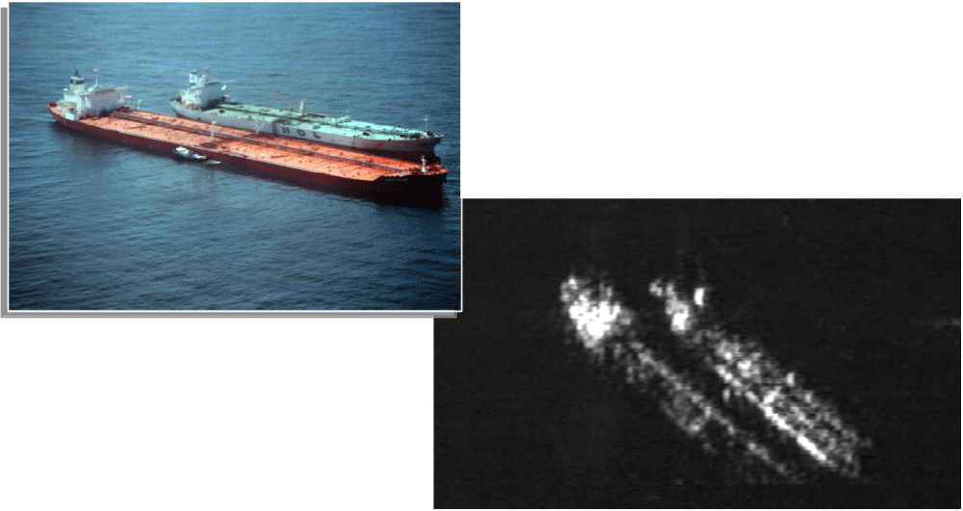
Figure 64. Typical ISAR Display (courtesy of AN/APS-137).

CHAPTER V CURRENT AND FUTURE STATE OF RADAR

Radar systems will continue to shrink in size while increasing in capability due to the demand for improved radar systems. Our military armed forces create the largest demand. Unmanned air vehicles (UAV) are the wave of the future in an effort to keep our soldiers out of harms way. UAVs will be required to stay on station (loiter around area of interest) longer and carry the same operational features as our most advanced aircraft. In addition to UAVs, the government will demand more performance and more capabilities in their current satellite systems such as spy satellites, GPS satellites, and weather satellites. Our civilian needs are great as well. Improvements are required for early detection of severe weather and improved air traffic control. As new technologies are introduced, radar upgrades must be made to take advantage.
Radar will improve as new techniques are discovered, current technologies are improved, and new technologies are created. These items will have the most impact on the five major radar components:
- Antenna
- Receiver
- Transmitter
- Video Processor
- Control Processor
As more and more functions such as satellite TV, GPS signals, telephone, wireless Internet, etc are coming to the home, the need for a signal point antenna is going to be required. Current technology and cost prohibit these from becoming a reality. Without a single point antenna, the roof would like a sea of antennas. As time goes on, more and more radar systems will be comprised of AESA antennas. In order to support this evolutionary process, the cost and manufacturability of T/R modules must decrease to level that is affordable to the average citizen. In addition, the radiated power levels must increase to yield an effective operating range.
Receivers may be eliminated altogether with advent of direct digital down conversion. The point at which the analog signal is converted to digital has been on a slow path towards the antenna for some time. It was not long ago when most of the radar was analog. As time went on, the receiver has become smaller and smaller. If the receiver were eliminated altogether, this would eliminate the need for single or dual down conversion stages currently employed in most radar. In order for this to materialize, the speed of the ADC devices must grow dramatically – 100 fold. Current state of the art ADC devices approach 3 GSPS (samples per second). In addition, video processors must be capable of receiving and processing 10 to 100 times more samples.
New technologies must be invented to improve the transmitter. As it stands today, it takes a lot of source power to create the desired effective radiated power (ERP) at the antenna. To reduce the source power while increasing or maintaining the ERP of the radar will require new technologies. New ways to excite and amplify electrons must be developed. In addition, new ways to cool transmitters must be developed. Current TWTs that produce an average power of 250 Watts, must used a large fan blowing directly across the tube in order to keep it cool.
Today’s video processors utilize multiple Power PC devices from Motorola such as those found in Apple Desktop Computers for general purpose processing and digital signal processing (DSP) devices from Texas Instruments for digital signal processing. As these devices continue to improve in speed and features, more radar modes/techniques can be employed to enhance the radar. Just in the last few years, the quantity of devices and surrounding hardware has decreased 4:1 while improving performance. [ACM 2000] In 10 to 20 years, processors running quantum-computing algorithms should see immense improvements. Instead of operating in a single state space, the quantum-computing algorithm makes use of all four states spaces allowing multiple operating simultaneously.
Control processors utilize Power PCs made by Motorola with specialized I/O such as Fibre Channel, Ethernet, Infiniband, VME, etc. The future state of this component will follow the video processor in regards to the processor and will follow the industry in regards to control interfaces discussed above.
REFERENCES

Abex, Varian TWT Photo,
http://www.abex.co.uk/sales/microwave/amplifiers/power/varian/vtm6292u1/item.htm

ACM Computing Surveys, Vol. 32, No. 3, September 2000, pp 300-335

Broadcast Microwave Services, Omni Antenna Photo,
http://www.raytheon.com/newsroom/photogal/dd21_l.htm

Brookner, E., “Radar Technology”, 1977, Artech House Inc. Dedham, Mass., pp. 22-33.

Flann Microwave, Omni-Direction Antenna Pattern Photo,
http://www.flann.com/Products_Home/Antennas/Omni-Directional/omni-directional.html

Gallawa, J, Magnetron Photos,
http://www.gallawa.com/microtech/magnetron.html

Global Security, AN/FPS-85 Radar Photo,
http://www.globalsecurity.org/space/systems/an-fps-85.htm

Greenman, M, Chirp Waveform Photo,
http://www.qsl.net/zl1bpu/micro/SIGGEN/Siggen.htm

Lycos, TWT Description Photo,
http://mitglied.lycos.de/radargrundlagen/roehren/tu28-en.html

McGee, D, “Principles of Radar”, 1993, Raytheon, Dallas, Texas

Credowan, Duplexer/Coupler Photo,
http://www.credowan.co.uk/microwavedevices.htm

Naval Air Command, AN/APG-79 Radar Photo,
http://pma265.navair.navy.mil/Public Affairs/Newsletters/2003/0203.html

Naval Air Warfare Center, AN/FPS-16 Radar Photo,
http://www.nawcwpns.navy.mil/~pacrange/RANGEWEB/section4/sect4a.html

Naval Technology, AN/APG-65 Radar Photo,
http://www.naval-technology.com/projects/harrier/harrier5.html

Pozar D., “Microwave Engineering”, 1990, Addison-Wesley Publishing Company Inc., New York, New York, pp. 686-687.

Raytheon, DD21 Photo,
http://www.raytheon.com/newsroom/photogal/dd21_l.htm

Raytheon Space and Airborne Systems, AN/APS-137 Radar Displays, McKinney Texas.

Remcom, Planar Array Corporate Feed Photo,
http://www.remcominc.com/html/array.html

Skolnik, M., “Introduction to Radar Systems”, 1980, McGraw-Hill Inc., New York, New York, pp. 8-12, 15, 30.

Skolnik, M., ‘Radar Handbook’, 1970, McGraw-Hill Inc., New York, New York, pp. 8-31 – 8-36

Stimson, G., “Introduction to Airborne Radar”, 1983, Hughes Aircraft Company, El Segundo, California, pp. 3.

Technology Focus, AESA Photo for Eurofighter,
http://pub137.ezboard.com/ffighterplanesfrm8.showMessage?topicID=176.topic

TELE-satellite International Magazine, Satellite Dish Photo,
http://www.tele-satellite.com/TSI/02/01/lorenzen/

University of Wisconsin-Madison, Space Science and Engineering Center, Antenna Servo Photo,
http://cimss.ssec.wisc.edu/~gumley/tower/xband.html

US Army Camp Evans, SCR-268/270 Radar Photo,
http://www.infoage.org/SCR_270.html

US Army Technology, Patriot Antenna Photo,
http://www.army-technology.com/projects/patriot/

Wehner, D, “High Resolution Radar’, 1987, Artech House Inc. Boston, Mass., pp. 32-34.

